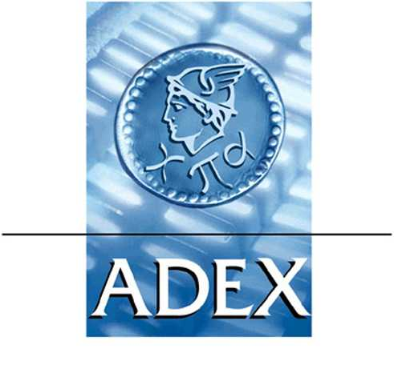
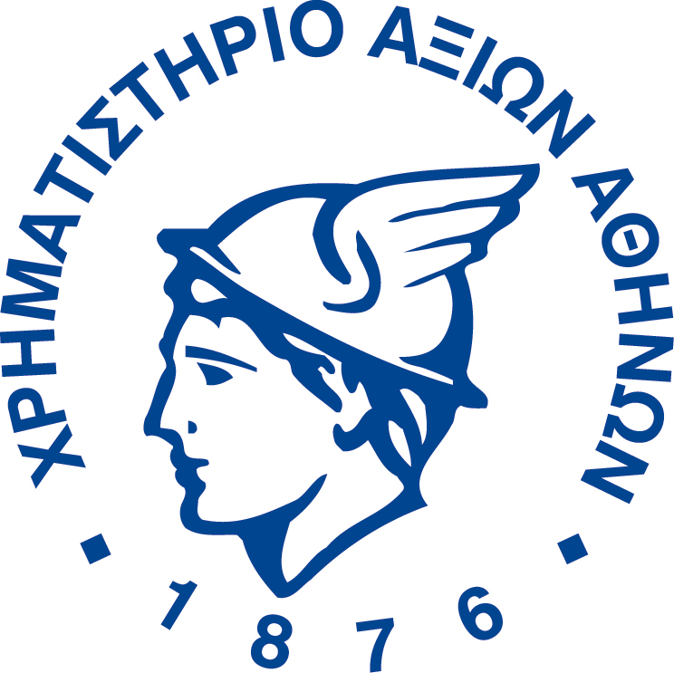

Athens 01 November 2002

PRESS RELEASE

The Index Committee approved the changes in the Athens Exchange indices according to the ground rules of indices management and operation. The ranking results from the mean of the net value of transactions’ rank and the average capitalization rank for the period 01/04/2002-30/09/2002. The changes will be effective after the close of business on the last trading day in 04 November 2002, that is on Monday, 4 November 2002.

Composite Share Price Index
 | SHARE
Shares listed  Total: 11 | NOTOS COM HOLDINGS S.A. (CR)
Shares listed  Total: 11 | ALPHA PORTFOLIO INVESTMENT S.A. (CB)
Shares listed  Total: 11 | ALTE S.A. (CR)
Shares listed  Total: 11 | DUTY FREE SHOPS S.A. (CR)
Shares listed  Total: 11 | MICHANIKI S.A. (CR)
Shares listed  Total: 11 | LAMPSA HOTEL S.A. (CR)
Shares listed  Total: 11 | VARVARESSOS S.A. (CB)
Shares listed  Total: 11 | EL. D. MOUZAKIS S.A. (CB)
Shares listed  Total: 11 | ETHNIKI S.A. GENERAL INSURANCE CO (CR)
Shares listed  Total: 11 | ASTIR PALACE VOULIAGMENI S.A. (CR)
Shares listed  Total: 11 | ERGO INVEST S.A. (CB)
Shares listed  Total: 11 | ALFA ALFA HOLDINGS S.A. (CR)
Shares listed  Total: 11 | ATTICA ENTERPRISES HOLDING S.A. (C)
Shares listed  Total: 11 | ELVAL S.A. (CB)
Shares listed  Total: 11 | UNISYSTEMS S.A. (CR)
Shares listed  Total: 11 | MOTOR OIL (HELLAS) REFINERIES SA (CR)
Shares listed  Total: 11 | G. GIANOUSIS S.A. (CR)
Shares listed  Total: 11 | MARFIN CLASSIC S.A. (CR)
Shares listed  Total: 11 | THESSALONIKA WATER & SEWERAGE SA (CR)
Shares listed  Total: 11 | FANCO S.A. (CR)
Shares listed  Total: 11 | KEKROPS S.A. (CR)
Shares listed  Total: 11 | HERMES REAL ESTATE S.A. (CΒ)

Parallel Market Price Index
 | ΟΝΟΜΑ ΜΕΤΟΧΗΣ
Shares listed  Total: 8 | INFORMATICS S.A. (CR)
Shares listed  Total: 8 | C. CARDASSILARIS & SONS - CARDICO S.A. (CR)
Shares listed  Total: 8 | PROMOTA HELLAS S.A. (CR)
Shares listed  Total: 8 | VARDAS SA (CR)
Shares listed  Total: 8 | NEORION NEW S.A. SYROS SHIP YARDS (CR)
Shares listed  Total: 8 | RAINBOW COMPUTER S.A. (CR)
Shares listed  Total: 8 | KLEEMAN HELLAS S.A. (CR)
Shares listed  Total: 8 | DUROS S.A. (CR)
Shares erased  Total: 7 | ELEKTRA IMPORTING S.A. (CR)
Shares erased  Total: 7 | GENER S.A. (CR)
Shares erased  Total: 7 | DIEKAT S.A. (CR)
Shares erased  Total: 7 | XIFIAS S.A. (CB)
Shares erased  Total: 7 | LIBERIS PUBLICATIONS S.A. (CR)
Shares erased  Total: 7 | ATTICA PUBLICATIONS S.A. (CR)
Shares erased  Total: 7 | FITCO S.A. (CR)

SECTORAL INDICES
WHOLESALE COMMERCE PRICE INDEX
 | ΟΝΟΜΑ ΜΕΤΟΧΗΣ
Shares listed  Total: 1 | PROMOTA HELLAS S.A. (CR)
Shares erased  Total: 11 | THE HOUSE OF AGRICULTURE SPIROU S.A. (CR)
Shares erased  Total: 11 | DUROS S.A. (CR)
Shares erased  Total: 11 | GEN. COMMERCIAL & IND.(CB)
Shares erased  Total: 11 | A. KALPINIS - N. SIMOS (C)
Shares erased  Total: 11 | ZAMPA S.A. (CB)
Shares erased  Total: 11 | CYCLON HELLAS S.A. (CR)
Shares erased  Total: 11 | ELTON S.A.(CR)
Shares erased  Total: 11 | ELGEKA S.A. (CR)
Shares erased  Total: 11 | MICROMEDIA - BRITANNIA S.A. (CR)
Shares erased  Total: 11 | SP. TASOGLOU S.A. (CR)
Shares erased  Total: 11 | YALCO - CONSTANTINOY S.A. (CB)

FOOD PRICE INDEX
 | ΟΝΟΜΑ ΜΕΤΟΧΗΣ
Shares listed  Total: 1 | P.G. NIKAS S.A. (CR)
Shares erased  Total: 1 | KRE.KA S.A. (CB)

INFORMATION TECHNOLOGY PRICE INDEX
 | ΟΝΟΜΑ ΜΕΤΟΧΗΣ
Shares listed  Total: 1 | ALTEC S.A. (CR)
Shares erased  Total: 1 | QUALITY AND RELIABILITY S.A.(CR)

RETAIL COMMERCE PRICE INDEX
 | ΟΝΟΜΑ ΜΕΤΟΧΗΣ
Shares listed  Total: 3 | ALFA-BETA VASSILOPOULOS S.A.(CR)
Shares listed  Total: 3 | ILEKTRONIKI ATHINON S.A. (CR)
Shares listed  Total: 3 | P. KOTSOVOLOS S.A. (CR)

TEXTILES PRICE INDEX
 | ΟΝΟΜΑ ΜΕΤΟΧΗΣ
Shares listed  Total: 1 | EL. D. MOUZAKIS S.A. (CB)
Shares erased  Total: 2 | TEXAPRET (CR)  G. GIANOUSIS S.A.

CONSTRUCTION PRICE INDEX
 | ΟΝΟΜΑ ΜΕΤΟΧΗΣ
Shares listed  Total: 2 | VIOTER S.A. (CR)
Shares listed  Total: 2 | INTRACOM CONSTRUCTIONS S.A. (CR)
Shares erased  Total: 1 | ATHENA S.A. (CR)

HOLDING PRICE INDEX
 | ΟΝΟΜΑ ΜΕΤΟΧΗΣ
Shares listed  Total: 2 | TECHNICAL OLYMPIC S.A. (CR)
Shares listed  Total: 2 | ELLΙNIΚΙ TECHNODOMIKI TEB ΑΕ (CR)

INVESTMENT PRICE INDEX
 | ΟΝΟΜΑ ΜΕΤΟΧΗΣ
Shares listed  Total: 5 | ARROW CLOSED END ΙNVEST.FUND.S.A. (CB)
Shares listed  Total: 5 | THE GREEK PROGRESS FUND S.A. (CB)
Shares listed  Total: 5 | EXELIXI S.A. (CR)
Shares listed  Total: 5 | PIRAEUS INVESTMENT S.A. (CB)
Shares listed  Total: 5 | COMMERCIAL INVESTΜΕΝΤ S.A. (CB)

PUBLISHING & PRINTING PRICE INDEX
 | ΟΝΟΜΑ ΜΕΤΟΧΗΣ
Share erased  Total:1 | INFORM P. LYKOS S.A. (CR)

NON METALLIC MINERALS & CEMENT
 | ΟΝΟΜΑ ΜΕΤΟΧΗΣ
Shares erased  Total:1 | CERAMICS ALLATINI S.A. (CB)

I.T. EQUIPMENT-SOLUTIONS PRICE INDEX
 | ΟΝΟΜΑ ΜΕΤΟΧΗΣ
Shares listed  Total: 2 | INFORMATICS S.A. (CR)
Shares listed  Total: 2 | CPI COMPUTER PERIPHERALS INTER/NAL (CR)
Shares erased  Total: 2 | ALTEC S.A. (CR)
Shares erased  Total: 2 | DESPEC TECHNOLOGY HOLDINGS S.A. (CR)

INDUSTRIALS PRICE INDEX
 | ΟΝΟΜΑ ΜΕΤΟΧΗΣ
Shares listed  Total: 7 | EL. D. MOUZAKIS S.A. (CB)
Shares listed  Total: 7 | P.G. NIKAS S.A. (CR)
Shares listed  Total: 7 | SHELMAN S.A. (CR)
Shares listed  Total: 7 | NEORION NEW S.A. SYROS SHIP YARDS (CR)
Shares listed  Total: 7 | ALUMIL MILONAS ALUM. IND. S.A. (CR)
Shares listed  Total: 7 | KLEEMAN HELLAS S.A. (CR)
Shares listed  Total: 7 | DUROS S.A. (CR)
Shares erased  Total: 8 | INFORM P. LYKOS S.A. (CR)
Shares erased  Total: 8 | XIFIAS S.A. (CB)
Shares erased  Total: 8 | LIBERIS PUBLICATIONS S.A. (CR)
Shares erased  Total: 8 | THRACE PLASTICS S.A.(CB)
Shares erased  Total: 8 | ATTICA PUBLICATIONS S.A. (CR)
Shares erased  Total: 8 | CERAMICS ALLATINI S.A. (CB)
Shares erased  Total: 8 | FITCO Α.Ε. (ΚΟ)  G. GIANOUSIS S.A.

The following indices have no additions or deletions:
Bank, Telecommunications, Basic Metals, Insurance, Real Estate & Oil Refineries Price Index .
Finally, the Television & Entertainment Price Index is deleted since the sector of Television & Entertainment has split into Lucky Gaming and according the paragraph 6.5.1 of the rules (Sectoral Indices are cancelled when the sectors they represent: Include less than 3 listed companies or The Total Average Market Capitalization is less than or equal to 0.5% of the Total Average Market Capitalization of the Market of Shares of the Athens Stock Exchange. ).

