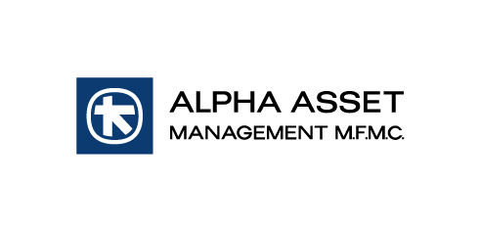
ALPHA ETF FTSE Athex Large Cap EQUITY UCITS
CAPITAL RETURN WITH REINVESTMENT INTO ETF's SHARES

Athens, 30 June 2024

Pursuant to the relevant announcement on 25 June 2024, ALPHA ASSET MANAGEMENT M.F.M.C wishes to inform investors that the total amount of the capital return according to the mutual fund's valuation on 30 June 24, is Euro 1,261,811.25 (i.e. 1.35 Euro per share) for all shareholders of the ALPHA ETF FTSE Athex Large Cap EQUITY UCITS of record with the Dematerialized Securities System ("DSS" or "SAT") of the Athens Exchange as of 2 July 2024 (record date). As of 1 July 2024, the currently listed shares will trade at the reduced price of Euro 33.52 and without the right to the capital return.
The reinvestment of capital will be completed on 3 July 2024 and the number of new shares will be calculated based on the ETFS's closing price (NAV) as of that date. The fund's new shares will be listed in the Athens Exchange on 4 July 2024, at which date shareholders will be credited with the additional shares. Any fractional shares will be returned to shareholders in cash.
As of 15 July 2024, the cash will be paid to shareholders through Alpha Bank in the following ways:
1. Through the operators of the beneficiaries in the DSS (Banks and Brokerage Firms), in accordance with the Rulebook of the Hellenic Securities Depository.
2. Especially in cases of dividend payment to heirs of deceased beneficiaries, whose securities are kept in the Special Account of their Share in the DSS under the management of ATHEXCSD, dividend payment process will be carried out after the completion of the legalization of heirs, through Alpha Bank network.

Dividends that will not be collected within five (5) year period, shall be barred in favour of the Greek State.

For any additional information shareholders may contact ALPHA ASSET MANAGEMENT M.F.M.C. at the telephone numbers +30 210 343 6571-72.

ALPHA ASSET MANAGEMENT M.F.M.C
General Commercial Registry 920101000
HCMC 21/2/19.5.1989 & HCMC 16/391/20.7.2006
45 Panepistimiou Street
GR-105 64 Αthens

Τel. : +30 210 326 6505
Fax : +30 210 326 6506
E-mail: info@alphaasset.gr

