Participant - Intermediary user Registration in the AXIA service

This procedure is followed in the event that an Intermediary/Participant wishes to upload identification files at the format of iso 20022 standard without use SWIFT Finplus services and to be able to monitor the files which sent, as well as the responses received through the AXIA platform.
The following actions are required to register a Participant/ intermediary in the AXIA platform:
1. The intermediary/Participant sends to ATHEXCSD the form AIT063E fully completed and signed by the legal representative of the company, with attached the representation and the certificate of good operation of the company or its registration in the relevant Registry.
2. ATHEXCSD registers the user's details in the AXIA platform, as stated in the application, linking them to the already existing registration for the specific intermediary (the details registered are: first name, last name, email and mobile phone with a selection of the country of destination mobile phone).
3. AXIA platforms sends the user an email containing a link for its initialization. The mail has the following format:
From: AXIAeShareholdersMeeting@athexgroup.gr
Date: Tue, 23 May 2023, 11:04
Subject: AXIA e-Shareholders Meeting Services
To: user
You are receiving this message because you have requested the creation of an account in the AXIA platform for your participation in General Meetings.
To activate your account follow the service activation link
4. The user, by pressing the activation link, enters a password of his choice, according to the rules set by the application (at least 8 characters, at least 1 capital, at least 1 numeric character and at least 1 special character). Next, re-enter the password for confirmation and select send otp by sms. As soon as it receives it, it registers it in the corresponding field and the activation is completed.

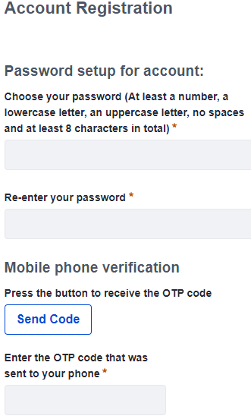
Connecting at the website: https://axia.athexgroup.gr/ords202/web/f?p=103:LOGIN_DESKTOP:
The user log in at the platform by entering username & password on the screen below (as username he enters the email he entered in AIT063E and as password the corresponding one he entered when he registered in the application):

