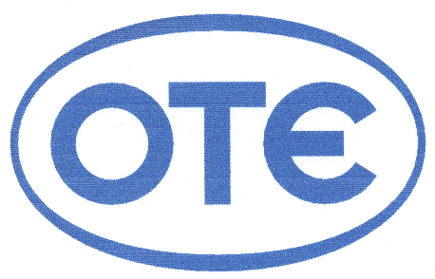
Announcement

Athens, Νοvember 28, 2006 – The Hellenic Telecommunications Organisation SA (OTE SA), as parent company of Cosmote SA proceeds in the present announcement, according to article 5 of the Presidential Decree 51/1992 in combination with the second part of Article 7, paragraph 1 and Article 8, paragraph 1a, of the same Decree.

Specifically, Cosmote SA, beyond the 20.75% on the total of voting rights of Germanos SA that possesses directly and the 63.82% that possesses indirectly, acquired, on Monday 27^{d} November 2006, 791,540 shares of Germanos SA, through the purchasing by its affiliated company Cosmoholding Cyprus Ltd. Thus, Cosmote SA will possess indirectly the 64.79% of the shares, which corresponds to the same percentage on the total voting rights of GERMANOS SA.

    - Percentage of shares before the amendment :
20.75%, with the corresponding voting rights, directly
84.58%, with the corresponding voting rights, directly and indirectly
    - Percentage of shares after the amendment:
20.75%, with the corresponding voting rights, directly
85.55%, with the corresponding voting rights, directly and indirectly
    - Number of shares before the amendment :
16,929,103, with the corresponding voting rights, directly
68,993,895, with the corresponding voting rights, directly and indirectly
    - Number of shares after the amendment:
16,929,103, with the corresponding voting rights, directly
69,785,435, with the corresponding voting rights, directly and indirectly.

INVESTOR RELATIONS
Τel. 210-611-1574/5070/1121
E-mail: dtzelepis@ote.gr
Fax. 210-6111030

