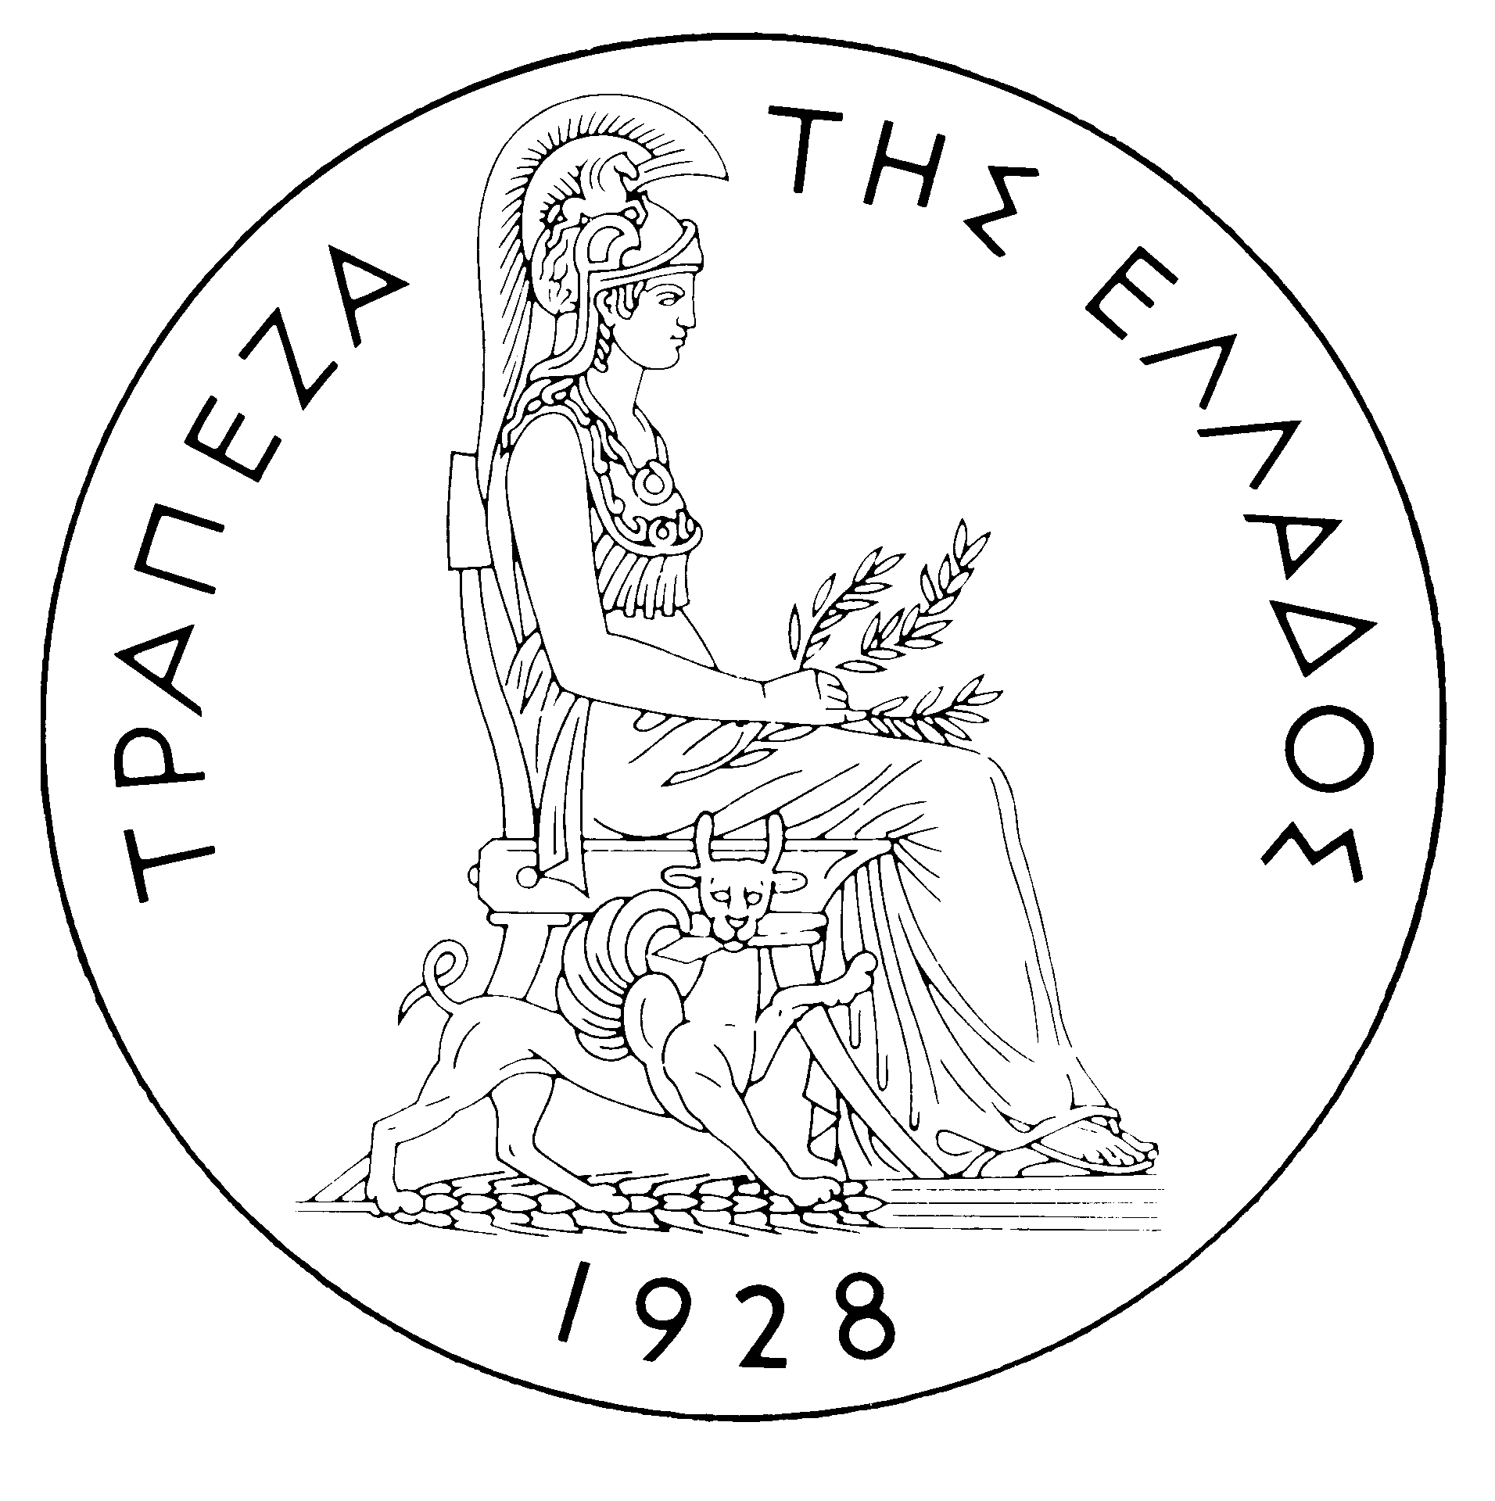
BANK OF GREECE

PRESS RELEASE

Athens, 20 July 2006

Re: Balance of payments: MAY 2006

Current account balance
In May 2006, the current account deficit came to €1,931 million, compared with €703 million in the corresponding month of 2005. This development is attributable mainly to the fact that payments for purchases of ships were higher (by €325 million) than receipts from sales of ships (while in May 2005 there was a positive balance of €107 million). The widening of the current account deficit is also accounted for by increases in the trade deficit excluding oil and ships and in the income account deficit (of €274 million and €286 million respectively), as well as by the narrowing of the services surplus and the current transfers surplus (by €198 million and €66 million respectively).
The rise in the trade deficit reflects, in addition to the outturn of the ships’ balance, also the fact that, although receipts from goods exports (excluding oil and ships) grew by €179 million, the corresponding import payments rose by €453 million. By contrast, the net oil import bill declined slightly (by €28 million).
The decrease in the surplus of the services balance reflects declines in net transport and travel receipts (of €119 million and €10 million respectively) and a €69 million increase in net payments for “other” services. Moreover, the rise in the income account deficit was accounted for by a rise mainly in dividend and profit payments and secondarily in interest payments on Greek government bonds held by non-residents. Finally, the drop in the current transfers surplus reflects a €98 million decline in net current transfers from the EU, while net transfers to the other sectors of the economy grew by €31 million. It should be recalled that gross current transfers from the EU mainly include receipts from the Guarantee Section of the European Agricultural Guidance and Guarantee Fund (EAGGF) in the context of the Common Agricultural Policy and receipts from the European Social Fund, while current transfers to the EU include Greece’s contributions (payments) to the Community Budget.
In January-May 2006, the current account deficit widened by €5,040 million over the same period of 2005 and reached €12,196 million, reflecting mainly a rise in the trade deficit (both the oil and ships deficit and the other goods deficit) and, to a lesser extent, an increase in the income account deficit and a narrowing of the services surplus. The current transfers surplus remained virtually unchanged year-on-year.
Underlying the €3,525 million rise in the overall trade deficit (including oil and ships) is mainly a €1,259 million increase in the net oil import bill, while the increase in net payments for purchases of ships and the widening of the deficit excluding oil and ships contributed by €1,123 million and €1,143 million respectively. However, it should be pointed out that receipts from goods exports (excluding oil and ships) showed a remarkable rise (of €692 million or 17.8%), which, however, was more than offset by an increase (of €1,862 million or 15.0%) in the corresponding import bill.
The services surplus narrowed by €679 million, as a result of a drop in net transport receipts (because transport receipts, despite remaining high, declined by €55 million, while transport payments increased by €375 million), a hike in net payments for “other” services and, finally, a small decline in net travel receipts.
The income account deficit grew by €832 million (as net interest, dividend and profit payments increased) mainly owing to the growth of net interest payments as a result of a continuing rise in non-residents’ holdings of old and new issues of Greek Government bonds.
Finally, the current transfers surplus remained virtually unchanged, as the decrease in net (mainly EU) current transfers to general government was almost offset by a rise in net current transfers to the other sectors (excluding general government).
Capital transfers balance
In May 2006, the capital transfers balance showed a surplus of €279 million, €176 million higher than in May 2005. (Capital transfers from the EU mainly include receipts from the Structural Funds – except for the European Social Fund – and the Cohesion Fund under the Community Support Framework.)
In January-May 2006, the capital transfers balance recorded a surplus of €1,451 million, €426 million up year-on-year. This reflects almost exclusively a €446 million (or 42.9%) rise in EU capital transfers to general government.
Combined current account and capital transfers balance (according to the old method of presentation)
The combined current account and capital transfers balances (according to the old method of presentation) showed a deficit of €1,652 million in May 2006; in January-May 2006, this deficit reached €10,745 million, compared with €6,131 million in the same period of 2005.
Financial account balance
In May 2006, a net inflow of €519 million was observed under direct investment. Specifically, non-residents’ investment in Greece showed a large net inflow of €572 million, while there was a small net outflow of €53 million under residents’ investment abroad. Underlying non-residents’ large investment in Greece is chiefly an inflow of €392 million for the acquisition by DUBAI FINANCIAL of 31.5% of the capital of the banking group MARFIN FINANCIAL GROUP. It should be pointed out that these shares were sold to DUBAI FINANCIAL by non-residents; as a result, there was an equal decline in non-residents’ portfolio investment, implying that the financial account balance was not affected. Under portfolio investment, a substantial net inflow of €5,330 million reflects inflows of non-residents’ funds of €6,153 million for purchases of Greek government bonds, which were offset to a very small extent mainly by corresponding purchases by Greek investors abroad (worth €661 million). "Other" investment showed a net outflow of €4,011 million, mainly as a result of the growth of residents’ deposit and repo holdings abroad.
In January-May 2006, direct investment showed a net inflow of €893 million (compared with a net inflow of €59 million in the same period of 2005). This development is accounted for by a net inflow of €1,174 million for non-residents’ direct investment in Greece, which was partly offset by a net outflow of €281 million for residents’ direct investment abroad. Under portfolio investment, a net inflow of €6,085 million was recorded, as almost half of the inflow of non-residents’ funds for investment in Greece (mainly in bonds, of €9,926 million) was offset by outflows of residents’ funds for investment abroad (mainly in bonds). Finally, under “other” investment, a net inflow of €4,217 million is attributable to inflows of non-residents’ funds (of €11,003 million), primarily to deposits and repos, which, however, was partly offset by residents’ corresponding investment abroad.
At end-May 2006, Greece’s reserve assets were virtually unchanged, at €2.1 billion. (It should be recalled that, since Greece joined the euro area in January 2001, reserve assets, as defined by the European Central Bank, include only monetary gold, the "reserve position" with the IMF, "Special Drawing Rights", and Bank of Greece claims in foreign currency on residents of non-euro area countries. Conversely, reserve assets do not include claims in euro on residents of non-euro area countries, claims in foreign currency and in euro on residents of euro area countries, and the Bank of Greece participation in the capital and the reserve assets of the ECB.)
Note: Balance of payments data for June 2006 will be released on 18 August 2006.

