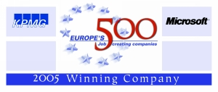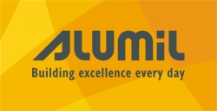

ALUMIL – PRESS RELEASE

ALUMIL: Group effort throughout Europe to fight labor discrimination & inequality with the collaboration of the Research Department - Ministry Education of France, the European Social Fund and Air France

Kilkis, December 21th, 2005,

A great cause over labor discrimination and distinction commences for the Group; promote uniqueness and differentiation for the employees as a comparative advantage for the company

For ALUMIL, a Group with clear international orientation, the coexistence of different profiles - employees, customers, other stakeholders – constitutes a fundamental and necessary condition το satisfy the goals and the vision of the company.

It further leads to innovation and creativity; allows synthesis of new ideas with a clearly productive mean. The company grows through a variety of origin, culture, civilization and professional knowledge; a harmonious composition of different generations.

ALUMIL evolves in different environments, different markets; aims in a combination between economic growth and social sensitivity. With faith in that, it participates actively in all efforts that tend to depict uniqueness a factor that promotes the company, the employees and all social partners.

Having this philosophy as a guide, parent company recently participated in the formation of a guide-chart for professionals in the Human Resources department, under the framework of the European program “Equal”.

This guide provides practical instructions for the minimization of labor discrimination and inequalities, due to racial or other criteria (religion, sex, age, etc). It is primarily directed to those who must choose, evolve and valuate employees; a heavy burden.

ALUMIL worked in this project in tandem with the Ministry of Education of France, the Research Department of the Ministry and Air France.
European Social Fund financed the above.

Please see attachment

Alumil Information: Mr. Stavros Bozikas (Corporate Human Resources Director),
Tel. +30 23410 79357, Fax: +30 23410 71988, E-mail: s.bozikas@Alumil.com

Mr. Apostolos Papadopoulos-Almeida (Communications officer),
Tel. +30 2310 555405, Fax: +30 2310 555425, E-mail: Investors@Alumil.com

