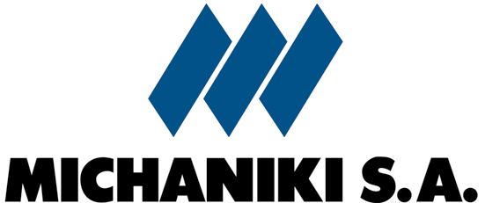

91 Meg. Alexandrou Street, Marousi 15124, Athens, Greece
Tel: +30210-8097100, Fax: +30210-8097145, e-mail: info@michaniki.gr
http://www.michaniki.com

September 29, 2005

H1 2005 Financial Results, under IAS

MICHANIKI S.A.: Net profit + 210%, Revenues +21%
MICHANIKI GROUP: Net profit + 14%, Revenues +0,5%

MICHANIKI SA is pleased to announce strong profitability growth in the first half of 2005, both at a group and a parent company level, due to an acceleration of contracts signed for new construction projects.
The financial statements of June 30, 2005 arre under International Accounting Standards (IAS).
At a parent company level, Michaniki SA turnover increased in the first half of 2005 by 21.3% to 45.6 million euros, from 37.6 million euros in the same period a year earlier.
EBITDA stood at 14.0 million euros in H1 2005, from 8.3 million the first half of 2004, marking an increase of 69.7%.
MICHANIKI S.A. net profit grew dramatically by 210% to 5.4 million euros, from 1.7 million in 2004.
MICHANIKI Group consolidated turnover increased marginally to 60.5 million euros versus 60.2 million euros.
Consolidated EBITDA increased by 107% to 24.9 million euros in H1 2005, from 12.0 million the year before.
Consolidated net profit, after minorities, grew 14.1% to 10.3 million euros, from 9.0 million euros in 2004.

Continued to page 2
From page 1

From the beginning of 2005 MICHANIKI signed contracts for the following public and private construction projects:

Project contract amount

- City of Agrinio Detour 31.1 m. euros
  - PATHE Highway: Section Skarfia-Lamia-Rahes 42.0 m. euros
  - Construction of Sykia Dam 96,4 m. euros
  - Road Works at the City of Patras, and Covering of
Diakoniaris river 46.1 m. euros
- E/M & Architectural works at Mediterranean Cosmos mall 14.0 m. euros
- Highway junction at Mediterranean Cosmos mall 2.1 m. euros
- Hydraulic works in the town of Pirgos and Olympia 11.4 m. euros
- Extention of Tinos island port 6.7 m. euros
- Contruction of a shopping mall in Peristeri (phase A) 1.4 m. euros

2005 year to date TOTAL: 251.2 million euros

MICHANIKI S.A. is also the preferred bidder for the construction of Piros-Parapiros Dam in Patras, western Greece, amounting to 74.6 million euros.

